**Data Analyst Assignment - Animemangatoon.com**

* Varun R
* 7760611993
* [thisisrvarun@gmail.com](mailto:thisisrvarun@gmail.com)
* <https://varun15r.github.io/>

**Article Analysis: "Why is the Tower of God Show So Popular?"**

**Assumed User Metrics:**

To analyze the user engagement trends, let's assume the following hypothetical data for user interaction metrics:

* **Page Views**: 10,000
* **Average Time Spent**: 3 minutes
* **Bounce Rate**: 45%
* **User Demographics**:
  + Age Groups:
    - 18-24: 55%
    - 25-34: 35%
    - 35-44: 10%

Data Visualizations:

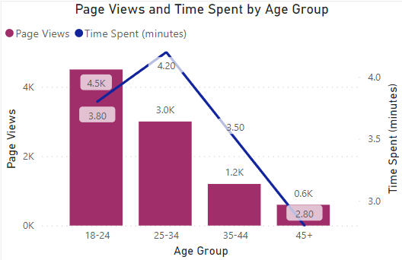

The bar chart compares the **page views** and **average time spent** on the article across four different age groups.

* **18-24 Age Group**: This group had the highest number of page views (4,500) but an average time spent of 3.8 minutes, which is slightly lower compared to older age groups.
* **25-34 Age Group**: With 3,000 page views, this group spends the most time on the page, averaging **4.2 minutes**. They are likely the most engaged with the content in terms of reading depth.
* **35-44 Age Group**: This age group has fewer page views (1,200) and a shorter time spent (3.5 minutes) compared to the younger groups, indicating a drop in interest or engagement.
* **45+ Age Group**: The smallest number of page views (600) comes from this group, who also spend the least time on the page (2.8 minutes), suggesting low engagement with the content.

**Summary**: The 25-34 age group seems to engage the most deeply with the article, while the younger 18-24 group generates the highest traffic but spends slightly less time on the content.

**Scroll Depth:**

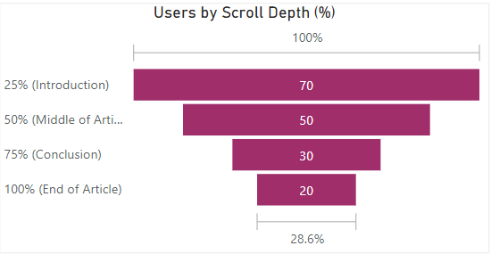

* **70%** of users scroll through **25%** of the article (likely reading the introduction).
* **50%** of users scroll through **50%** of the content, but engagement drops further toward the end.
* Only **20%** of users make it to the end of the article, indicating that the article loses a significant portion of users halfway through.

**Summary**: While many users start reading the article, a large portion drops off before reaching the conclusion, suggesting that adjustments to the structure or content flow may be needed to retain users’ attention.

**Bounce Rate by Device**

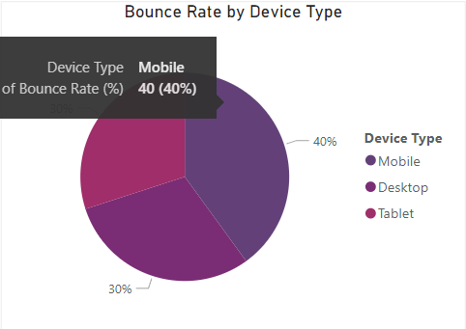

The pie chart illustrates the **bounce rate** (the percentage of users who leave the page without interacting much) by device type.

* **Mobile Users**: Contribute to the highest bounce rate at **40%**, indicating that mobile users might be finding the content less engaging or the layout may not be optimized for mobile viewing.
* **Desktop Users**: Have a lower bounce rate of **30%**, suggesting that desktop users are more engaged and spend more time interacting with the content.
* **Tablet Users**: Also contribute to **30%** of the bounce rate, similar to desktop users, but due to their small share of total users, this suggests that tablets aren't a primary device for viewing the article.

**Summary**: Mobile users make up the highest bounce rate, indicating a need for improved mobile optimization or content tailored specifically for mobile viewing. Desktop users, with a lower bounce rate, may be engaging more deeply with the content.

**Key Insights**

1. **Moderate Engagement**: While the article is popular with 10,000 views, the average time spent **3 minutes** suggests that users are not fully reading or engaging with the lengthy content.
2. **High Bounce Rate**: The **40% bounce** rate is quite high, indicating that many users are not fully exploring the page after landing on it, which may be a result of the content not capturing attention or being too long for some users.

**Suggested Strategies to Increase Average Time Spent**

**Incorporate Interactive Elements**:

* **Quizzes or Polls**: Adding interactive content, such as quizzes related to “Tower of God” characters or storylines, could engage users further and encourage them to stay on the page longer.
* **Embedded Videos**: Including embedded videos, such as clips from the series or fan-made compilations, can capture user interest and extend the time they spend on the page.

**Improve Content Structure for Better Readability**:

* **Quick Hook or Fun Fact**: Start with a hook, such as an interesting fact or stat about the anime/manga that might surprise or captivate the reader.
* **Brief Summary**: Follow up with a concise summary of the article's content in 2-3 sentences to set expectations.

**Article Analysis: "Refund High School Chapter 22-30: The New Arc of Mook"**

**Assumed Interaction:**

For this analysis, let's assume the following hypothetical user data for interaction metrics:

* **Page Views**: 7,500
* **Average Time Spent**: 2.5 minutes
* **Bounce Rate**: 40%
* **User Demographics**:
  + Age Groups:
    - 18-24: 50%
    - 25-34: 40%
    - 35-44: 10%
  + New vs. Returning Users:
    - New Users: 45%
    - Returning Users: 55%

**A/B Testing Strategy**

For this test, we will need to split the audience into two segments. Each segment will receive one of the two versions of the page (A or B). Track and compare the following metrics:

* **Average Time Spent**
* **Bounce Rate**
* **Scroll Depth**
* **Click-through Rate (CTR)**

**1. Test Headline Variations**

* **A/B Test 1: Engaging vs. Informative Headline** for example:
  + **Version A:** “Chapter 22-30: The New Arc of Mook Unfolds with Thrilling Twists”
    - Focus on intrigue and exciting elements to capture the user’s curiosity.
  + **Version B:** “Read Refund High School Chapters 22-30: Explore Mook’s New Journey”
    - A more direct and informative headline, clearly indicating what users can expect.

**Objective:** Determine which type of headline (engaging vs. informative) increases the click-through rate and average time spent on the page.

**2. Test Visual Changes**

* **A/B Test 2: Custom Art vs. Scene Stills**
  + **Version A:** Display **custom artwork** featuring key characters like Aru, Mook, and King Yemma in vibrant colors.
  + **Version B:** Use **stills from actual scenes** in the webtoon chapters to offer a preview of the storyline.

**Objective:** Test which visual representation boosts user engagement, leading to higher page views and lower bounce rates.

**3. Test Layout Adjustments**

* **A/B Test 3: Text Placement and Image Size**
  + **Version A:** Use **larger images with captions** to make the visuals the primary focus, placing the text slightly below the images to maintain visual appeal.
  + **Version B:** Prioritize **text over images**, using smaller image thumbnails and placing the text immediately below headlines.

**Objective:** Test which layout makes users stay longer on the page and consume more of the content.

**Case Study: "11 Best Solo Leveling Arcs in the Manhwa to Read Now" – User Segmentation and Content Personalization**

**1. User Segmentation Based on Demographics and Behavior**

In this analysis, we'll categorize users based on **demographics** and **behavior** while interacting with the article.

**A. Demographic Segmentation:**

1. **Age Groups**:
   * **18-24**: Likely the core audience, given the popularity of modern fantasy stories like *Solo Leveling* among young adults.
   * **25-34**: Another key segment, potentially long-term fans who have followed the series for years.
   * **35+**: A smaller segment, possibly interested in the nostalgic or strategic elements of the story.
2. **Gender**:
   * Manhwa readership trends suggest that a larger portion of the audience may be male due to the action and fantasy themes, but there is also notable female engagement, especially around character and emotional development.

**B. Behavioral Segmentation:**

1. **New vs. Returning Visitors**:
   * **New Visitors**: Users visiting the article for the first time, possibly through search engines or social media, interested in quick overviews or introductory content.
   * **Returning Visitors**: More engaged users who revisit the article to explore detailed analysis of specific story arcs or characters.
2. **Content Interaction**:
   * **Short Attention Span**: Users spending less than two minutes on the article, likely skimming or reading specific sections.
   * **Engaged Readers**: Users spending more than three minutes, exploring multiple sections of the article and reading in-depth.

**2. Personalizing Content for Each Segment**

Based on the user segmentation, the following content strategies can help tailor the article to each audience group:

**A. Personalization by Age Group**

1. **18-24 Age Group**:
   * **Focus**: This group prefers fast, dynamic content.
   * **Content Strategy**:
     + **Short, Visual Summaries**: Provide concise summaries of each arc paired with engaging visuals or GIFs from key scenes to cater to their need for quick, visually appealing content.
     + **Interactive Features**: Include quizzes or polls to boost engagement and create a personalized experience.
2. **25-34 Age Group**:
   * **Focus**: This segment appreciates more detailed analysis and deep dives into the story and character arcs.
   * **Content Strategy**:
     + **In-Depth Analysis**: Offer extended breakdowns of character development and key plot twists, focusing on themes like family and emotional bonds, as seen in *The Ahjin Guild Arc*.
     + **Exclusive Engagement Tools**: Provide downloadable content or exclusive insights to keep this audience connected.
3. **35+ Age Group**:
   * **Focus**: This group may seek nostalgia or strategic comparisons to older fantasy stories.
   * **Content Strategy**:
     + **Comparative Analysis**: Connect *Solo Leveling* arcs with classic fantasy themes from works like *Lord of the Rings* to draw in this audience.
     + **Recommendations**: Offer suggestions for other manhwas or related content that might appeal to this demographic.

**B. Personalization by Behavior**

1. **New Visitors**:
   * **Focus**: Provide clear, engaging entry points into the content.
   * **Content Strategy**:
     + **Introductory Summaries**: Start with a brief introduction to the *Solo Leveling* universe before delving into the arcs to familiarize new users.
     + **Call to Action**: Encourage new users to explore related content like "Top 10 Fantasy Manhwas."
2. **Returning Visitors**:
   * **Focus**: Offer deeper content to keep them engaged.
   * **Content Strategy**:
     + **Advanced Insights**: Provide detailed analysis and connections between arcs for long-time fans of the series.
     + **Community Engagement**: Create discussion forums or comments sections for returning visitors to engage with others and discuss their theories or favorite moments.
3. **Short Attention Span Users**:
   * **Focus**: Capture their attention quickly with exciting highlights.
   * **Content Strategy**:
     + **Highlight Key Arcs**: Focus on the most action-packed arcs like *The Final Battle* and *The Monarch’s War Arc*, using bold fonts and impactful quotes to draw attention.
     + **Infographics**: Create quick-read graphics to summarize key plot points for users who prefer skimming content.
4. **Engaged Readers**:
   * **Focus**: Provide more comprehensive content to match their interest level.
   * **Content Strategy**:
     + **Detailed Content**: Offer full recaps of arcs and deeper character studies for invested readers.
     + **Interactive Timelines**: Build timelines that track the progression of arcs to appeal to these highly engaged users.

**3. Conclusion: Strategies for Content Personalization**

By tailoring content to user demographics and behavior, engagement and retention can be significantly enhanced. Key strategies include:

1. **Visual and interactive content** for younger readers.
2. **Detailed analysis** for older, more engaged audiences.
3. **Clear entry points** and introductory content for new visitors, while offering deeper insights for returning users.
4. **Highlighting key moments** for users with shorter attention spans, while providing comprehensive content for more engaged readers.